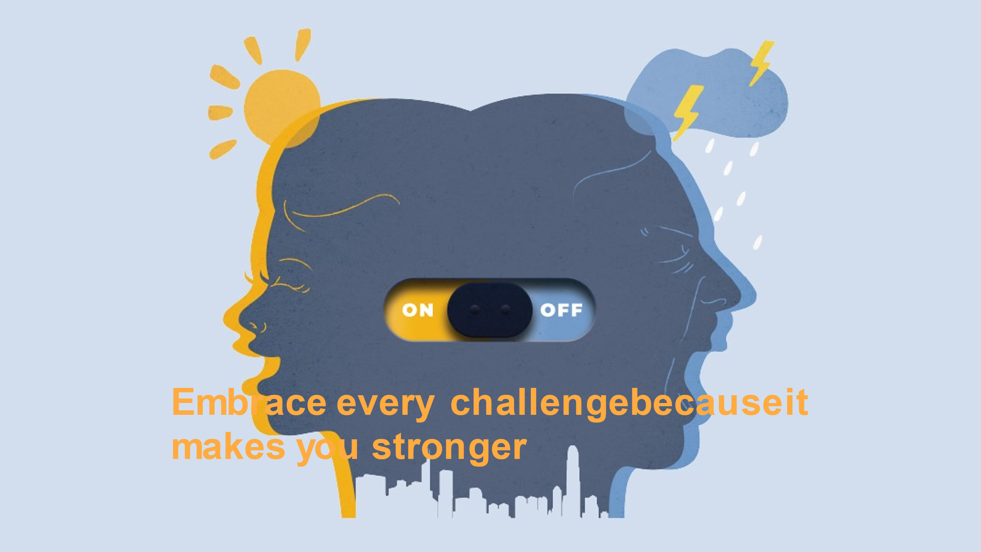
Student Art Contest Winner Prishna Patel, Conrad Schools of Science

Registration Now Open for “Pursuing Emotional Resilience” Conference

The pandemic has been a challenge for all of us. For well over a year, disrupted lives and routines have been the norm. Yet so many of us have persisted and survived! We’ve found new and creative ways to help ourselves and others! This virtual conference will highlight the resilience that educators, parents, and students have shown in the face of adversity and will offer suggestions for re-charging our “resilience batteries” as we move forward. Join us for a day of celebration and inspiration!
Dr. Jill Biden and Delaware’s First Lady Tracey Carney will open the conference. Featured speakers for the day include Pete Hall, co-author of the book Fostering Resilient Learners, and Elena Aguilar, author of the book Onward: Cultivating Emotional Resilience in Educators.
All attendees will receive a copy of Elena Aguilar’s book and a special commemorative t-shirt to mark the event!
Click https://cvent.me/OmRNOO to register.
Registration opens on March 30 and closes May 1.

