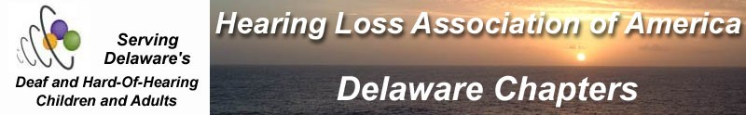

HEARING LOSS ASSOCIATION OF DELAWARE (HLADE)
(302) 388-9459
Email: hlade@comcast.net
Website: www.hlade.org
“We give help and hope to people with hearing loss”
Find us on facebook at facebook/Delaware Deaf and Hard of Hearing Connect
Newark Senior Center Group meets @10am, 2nd Wed every month!
NEW Nnew CHAT Groups start in the fall !
JUST COME AND JOIN US FOR OUR 2021 CHATS!!!
Topic: “What are the Stigmas of Hearing Loss?”
by Mary Anne Komorny,B.S.,B.A., Vice-President, HLADE

We are pleased to have Mary Anne Komorny be our guest speaker. Mary Ann just graduated with honors and received the Ackerman Prize from the University of Delaware with 3 Bachelor’s degrees and 4 minors. She just published her first paper on the Stigma of Hearing Loss. We look forward to her interesting talk!!

The Hearing Loss Association of Delaware (HLADE) will have its Wilmington informal Chat Support Group meeting on SATURDAY, June 10th from 10:00-11:15am at Newark Senior Center,200 Whitechapel Rd, Newark, DE 19713 Phone: (302)737-2336 (Hearing loop accessible!)

The group meets the 2nd Thursday of every month@10am in the Classroom wing. The room will have an HLADE sign on it. All are welcome to attend including friends and caregivers!
PURPOSE: The purpose of HLADE is for deaf and hard of hearing people of all ages with hearing loss or wear hearing aids, cochlear implants or use listening devices to meet, learn and help each other. Family, friends and parents anyone who wants to learn more about hearing loss is welcome to attend! Please share this information with anyone you know who has a hearing loss.

The Hearing Loss Association of Delaware (HLADE) is a non-profit, statewide, information, advocacy,education and support organization affiliated with the Hearing Loss Association of America (HLAA) and serves the Delaware region.

For more information, please visit the web at http://www.hlade.org Or call (302) 388-9459 (V/Text/cell or email at hlade@comcast.net. If you need this flyer in an accessible format, please contact HLADE.

